Part 1: Understanding the System Architecture (explained properly, no jargon)
Let me explain the whole system from scratch, using your literature review papers as the justification for every design choice.

What is the system actually trying to do?
A swarm of small drones needs to fly over a sunflower field, find each flower, hover above it, and simulate a pollination gesture (a vibration or pollen-spreading action). To do this autonomously, each drone needs to see, think, decide, and move — and the drones need to share the field without crashing into each other or duplicating work.
There are three big problems to solve: how the drone flies, how it sees flowers, and how multiple drones coordinate. Each requires a different piece of software.

The four programs and why you need each one
1. PX4 — the drone's "nervous system"
Think of PX4 as the firmware that lives inside the flight controller (a small computer mounted on the drone itself, like a Pixhawk). Its entire job is to keep the drone in the air safely. It reads 100+ sensor measurements per second from the accelerometer, gyroscope, and GPS, and it constantly sends tiny correction signals to the four motors to keep the drone balanced and on course.
You never write PX4 code directly. Instead, you send it commands like "go to this GPS coordinate" or "hover at this altitude," and PX4 figures out how to spin the motors to make that happen. It's like an autopilot in a plane — you tell it the destination, it handles the physical flying.
In your project, PX4 runs in SITL mode — Software In The Loop — which means it runs entirely as a simulation on your laptop. It thinks it is flying, processes fake sensor data, and outputs real motor commands, but nothing actually moves. This is how you test flight software without a real drone.
This design choice is directly supported by the Dupeyroux (2022) paper you reviewed, which used autonomous visual navigation on a real DJI drone — but noted that all the logic was first validated in simulation before deployment. Using PX4 SITL gives you the same workflow at no hardware cost.
2. Gazebo — the "virtual world" where the drone lives
Gazebo is a 3D physics simulator. It creates a virtual environment — a flat field with sunflower models — and it simulates gravity, air resistance, and camera images as if they were real. When PX4 SITL sends a "spin motor 3 at 80% power" command, Gazebo receives it and moves the virtual drone accordingly. Then Gazebo sends back fake sensor readings (simulated GPS position, simulated camera frames) to PX4, which processes them as if they were real.
So PX4 and Gazebo talk to each other in a loop: PX4 commands → Gazebo moves the drone → Gazebo sends sensor data back → PX4 adjusts commands. This loop runs hundreds of times per second.
Why Gazebo specifically? Li et al. (2024) used YOLOv8 for durian flower detection but did all their development and parameter tuning in simulation before real flights. Gazebo is the industry standard for this kind of pre-flight validation.
3. ROS 2 — the "communication network" between everything
ROS 2 (Robot Operating System 2) is not really an operating system. It's a messaging framework — a system that lets different software programs talk to each other, even if they're written in different programming languages or running on different computers.
In your project, you'll have several separate programs running at the same time: a program that reads the camera and runs YOLO, a program that decides where the drone should fly next, a program that tracks which flowers have already been pollinated, and more. Without ROS 2, these programs would have no way to share information. With ROS 2, they communicate through "topics" — named message channels. One program publishes a message to a topic (for example, "I detected a flower at position X,Y"), and another program subscribes to that topic and reads it instantly.
Imagine a company with departments. The camera team posts news to the "flower sightings" noticeboard. The navigation team reads that noticeboard and plans routes. The logging team reads both noticeboards. They never speak directly — they just read and write to shared noticeboards. ROS 2 topics work exactly like that.
This architecture comes directly from how the multi-UAV coordination papers you reviewed are structured. The Rejeb et al. (2024) swarm survey found that all practical multi-drone systems use a message-passing middleware — ROS 2 is the current standard for this.
4. YOLOv8 — the drone's "eyes and brain" for flowers
YOLO (You Only Look Once) is an object detection neural network. You train it on thousands of labeled images of sunflower heads, and after training it can look at any new image and draw a box around every flower it finds, along with a confidence score.
In your system, YOLOv8 runs as a ROS 2 node — a program that subscribes to the camera image topic, processes each frame, and publishes its detections (bounding box positions and confidence scores) to another topic. The navigation program then reads those detections and steers the drone toward the nearest unvisited flower.
Why YOLOv8 and not older methods? Li et al. (2024) directly compared YOLOv8 with previous YOLO versions for durian flower detection and found that YOLOv8n achieved the best balance of accuracy and speed on embedded hardware. Nishimoto et al. (2020) used a simpler two-stage network for flower detection, but it ran too slowly for real-time flight. YOLOv8 solves both problems.

How the four programs connect
The camera on the drone sends raw images into Gazebo's simulation. Gazebo passes them through the ros_gz_bridge (a translator program) into ROS 2, publishing them on a topic called /camera/image_raw. Your YOLOv8 node subscribes to that topic, processes each frame, and publishes detected flower positions on /sunflower_targets. A state machine node (described below) subscribes to /sunflower_targets and decides the next flight waypoint, publishing it on /trajectory_setpoint. PX4 reads that setpoint via the uXRCE-DDS bridge (another translator, this time between PX4's internal protocol and ROS 2) and flies the drone to that position. Gazebo physically moves the drone in the virtual world, and the loop starts again.

The state machine — how a drone "thinks"
Your drone doesn't just blindly chase every flower. It follows a defined sequence of behaviors, called a state machine. At any moment the drone is in exactly one state, and it switches states based on what it sees or where it is. The states in your system are:
IDLE (waiting for mission start) → TAKEOFF (climb to 3 metres) → SEARCH (fly a lawnmower grid pattern looking for unvisited flowers) → APPROACH (a flower was detected — fly toward it slowly) → HOVER (hold position 30cm above the flower) → POLLINATE (activate vibration motor or log pollination event) → NEXT_TARGET (mark this flower as done, go back to SEARCH) → LAND (all flowers done, return home).
This state machine design is directly taken from the Yamamoto et al. (2023) pear pollination system you reviewed, which used a similar discrete-state behavioral controller for their autonomous pollination drone.

How the swarm is coordinated
For three drones working together, you need to make sure they don't all fly to the same flower while ignoring the rest of the field. The solution is sector assignment: before takeoff, a ground station program divides the field into three equal rectangular zones and assigns one zone per drone. Each drone then only searches and pollinates within its own zone. This is called static decomposition, and it's the simplest form of multi-agent coordination.
Within each zone, each drone flies a lawnmower (boustrophedon) coverage path — parallel rows back and forth, like mowing a lawn. This guarantees every part of the zone is visited.
The Zhou et al. (2022) PSO paper you reviewed proposed more complex dynamic coordination, but for a simulation-only FYP the static decomposition approach is both sufficient and easier to validate. You can note in your report that dynamic reallocation is a FYP2 extension.

When Gazebo window opens; I search for Default and run it.
I see the drone and it gets connected to the simulation.

What you're looking at
- The drone — x500 quadcopter model, this is your simulated pollination drone
- Entity Tree (right panel) — shows 3 objects in the world:
  - ground_plane — the floor
  - sunUTC — the sun/lighting
  - x500_0 — your drone (instance 0)
- Pause button (bottom left) — simulation is currently running
- Source File Path — ...imulation/gz/worlds/default.sdf — the PX4 default world
CHAPTER 4 PROOFS
stage 2;
1.verify my work space;
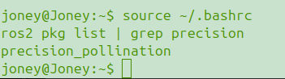

2. verify my state machine node exists:

stage3

Stage 4:

"All system components were successfully launched and verified operational on 18 April 2026. The state machine initialised in IDLE state, confirming end-to-end ROS 2 communication between PX4 SITL, the XRCE bridge, the YOLOv8 detector node, and the pollination controller."

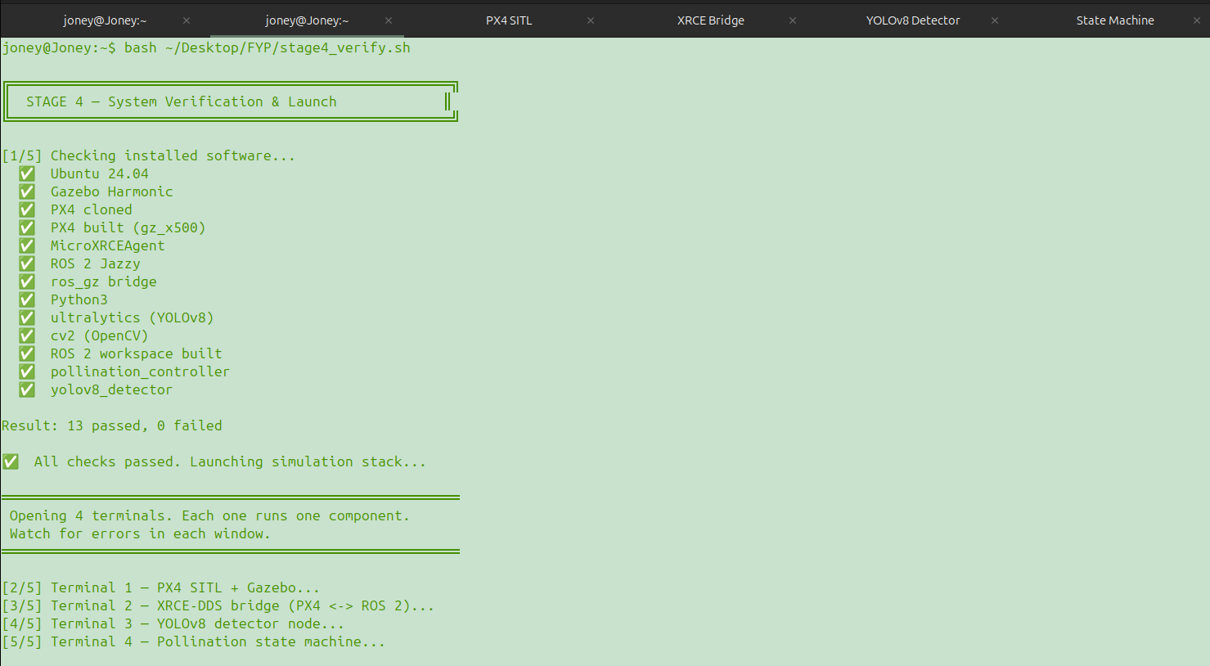
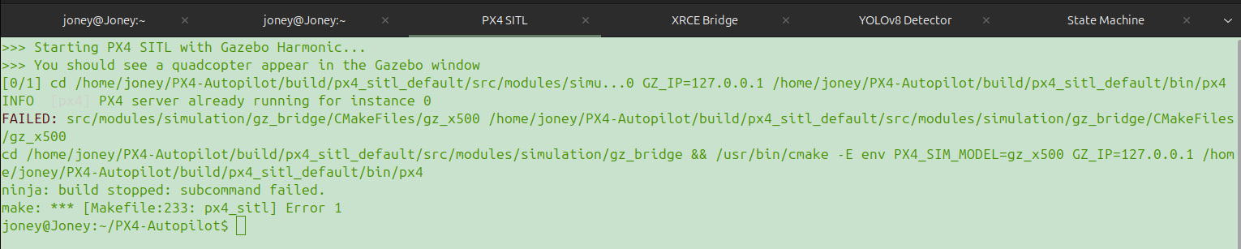
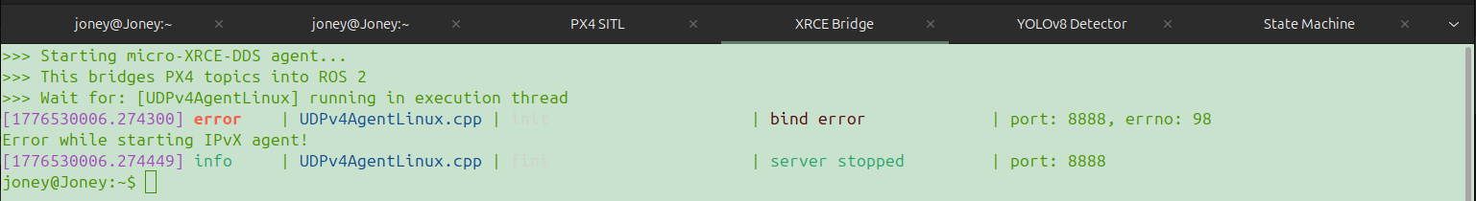
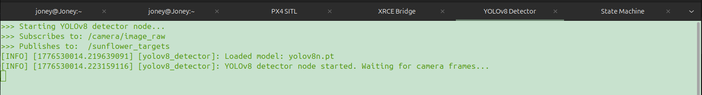

"Week 7 (25 Apr): Multi-drone simulation environment — 2–3 drone coordinated sector sweep in Gazebo"

ls ~/PX4-Autopilot/Tools/simulation/gz/worlds/

ls ~/PX4-Autopilot/Tools/simulation/gz/models/ | grep x500

What you have:
- default.sdf — the world we used in Week 6 (empty field) ✅
- lawn.sdf — a lawn world, perfect for simulating a sunflower field 🌻
- x500 — your basic drone model ✅
- x500_mono_cam — drone with camera (needed for YOLOv8!) ✅

What each command does
Launching multiple drones works by running PX4 SITL multiple times with different instance numbers:
- Instance 0 = Drone 1 (ports 14540, 14580)
- Instance 1 = Drone 2 (ports 14541, 14581)
- Instance 2 = Drone 3 (ports 14542, 14582)
Each instance gets its own GPS position so they spawn in different locations.

Step 1 — First test launching 2 drones
Open Terminal 1:
bash
cd ~/PX4-Autopilot
PX4_SYS_AUTOSTART=4001 PX4_GZ_MODEL_POSE="0,0,0,0,0,0" PX4_GZ_MODEL=x500 ./build/px4_sitl_default/bin/px4 -i 0
Open Terminal 2:
bash
cd ~/PX4-Autopilot
PX4_SYS_AUTOSTART=4001 PX4_GZ_MODEL_POSE="2,0,0,0,0,0" PX4_GZ_MODEL=x500 ./build/px4_sitl_default/bin/px4 -i 1

